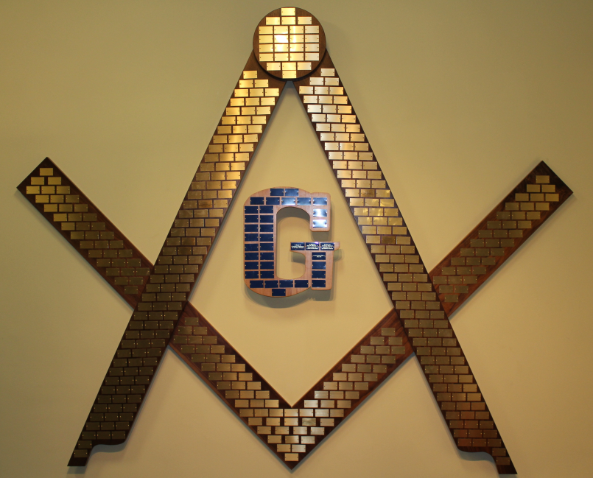
The Symbol of Light
At the Masonic Home of Virginia

The Symbol of Light, handcrafted by residents of the Masonic Home of Virginia, hangs in the Gallery as a testament to the generosity of the Home’s family of donors. The color of the plate identifies a distinct level of giving. The Rays, or brass plates, on the Square and Compasses are reserved for donations of $2,500, while the Beams, or blue plates, on the G are for donations of $5,000. Each plate will be engraved to the donor’s liking, the form for which is located below. Interested donors may call 1-800-262-4644, extension 77223 for more information, or fill out the form below and mail to:
Masonic Home of Virginia, P.O. Box 7866, Henrico, VA 23231-0366

Donor Name _______________________________________________________________
First Middle Last

Address ___________________________________________________________________
Street/PO Box City State Zip

Gift Amount: ____________________________ Telephone __________________________

In general, each Ray or Beam may contain up to 5 rows of text with 17 characters per row, including spaces and punctuation. However, we can work with you to fit your inscription. Please inscribe the plate as follows:
 | 1 | 2 | 3 | 4 | 5 | 6 | 7 | 8 | 9 | 10 | 11 | 12 | 13 | 14 | 15 | 16 | 17
1
2
3
4
5

